**Rent Bike**

Rent bike is a simple application for the rental solution that is easy to use.

How does it work?

*-Sign up or login*

*-Unlock a bike*

*-Enjoy the ride*

*-Return the bike*

The project consists of two technical parts: Windows Forms application and ASP.NET web application.

As an administrator using windows form application you can manage stations, bikes, and view statistics over the rents.

As a user using ASP.NET web application you can sign up, sign in, create rent, finish rent and check your own rent statistics.

Database:

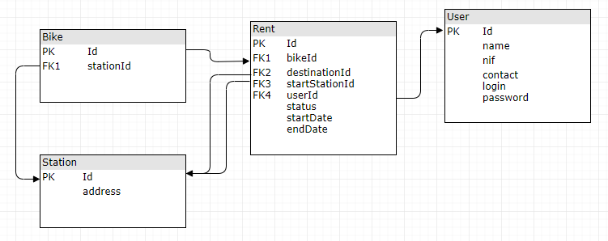

**Windows Forms application:**

Main page for the administrator

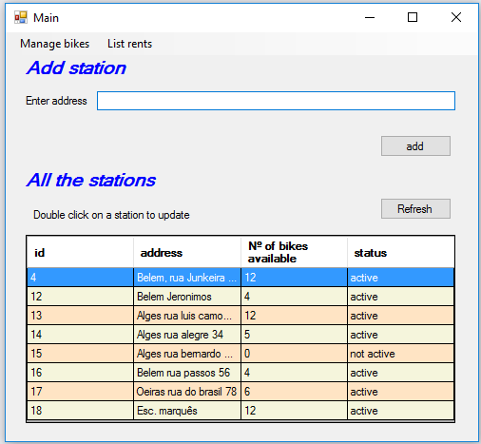

Add station example. The station will have status active automatically.

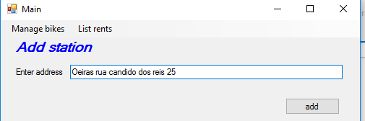

After adding the station, a list of station is refreshed automatically

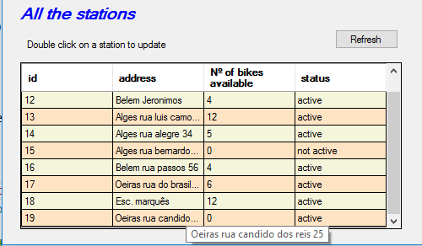

Update station window

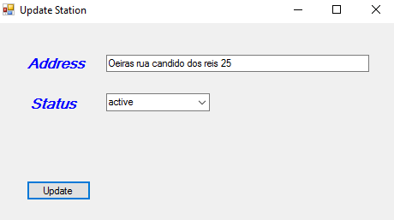

Manage bikes window

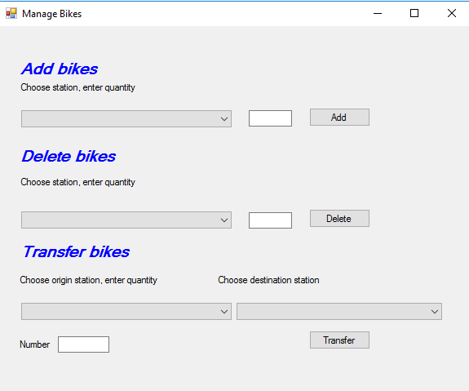

Example of adding bikes. Assuming all the bikes are equal. Only active stations are shown.

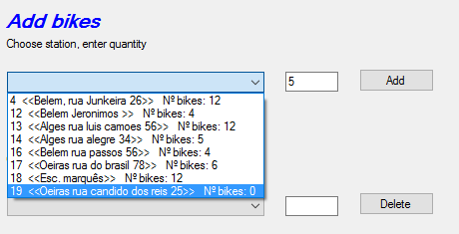

After adding bikes comboBox is updated

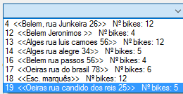

Transfer bikes example

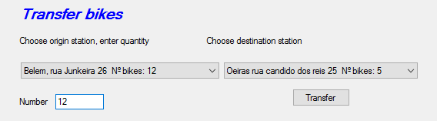

After transferring comboBoxes are updated

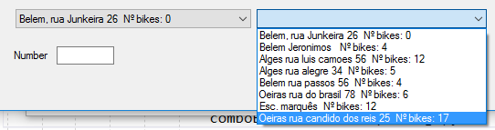

Rent´s statistic window

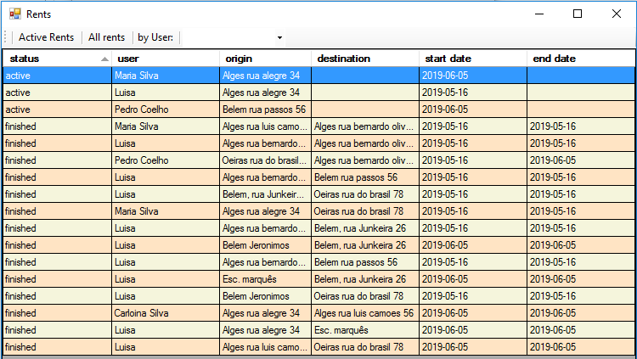

Here you can choose to show only Active Rents for example

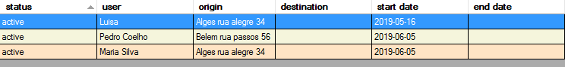

Or by user. Also you can sort rents by date and stations.

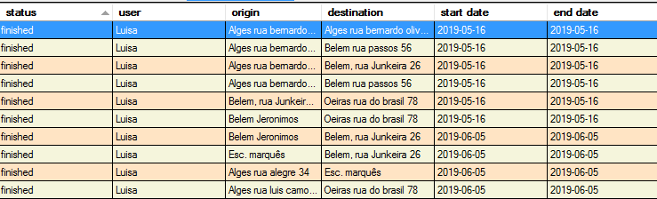

**ASP.NET web application:**

Here we have a main page

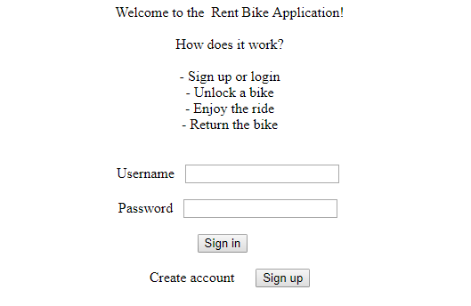

Sign up page, for example:

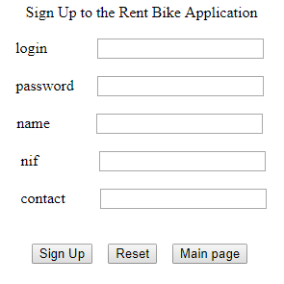

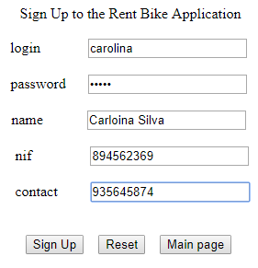

After signing up message is shown

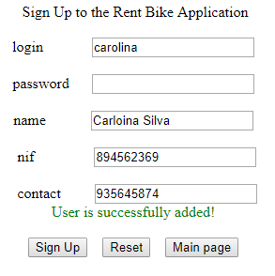

If click on sign up again alert message is shown

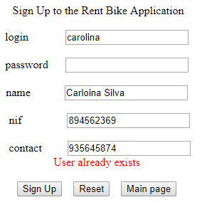

Example of table user

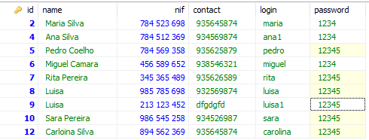

User´s page after logged in

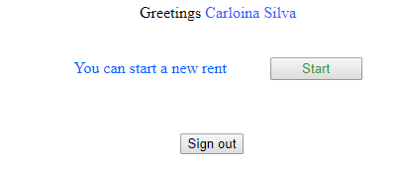

Start new rent page

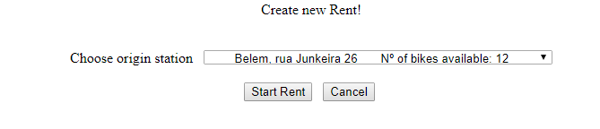

User can not choose station that has no bikes available. Also only active stations are shown for the user.

Confirmation page

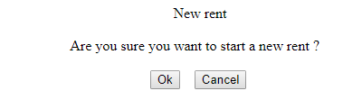

Updated user´s page. User can have one active rent at a time.

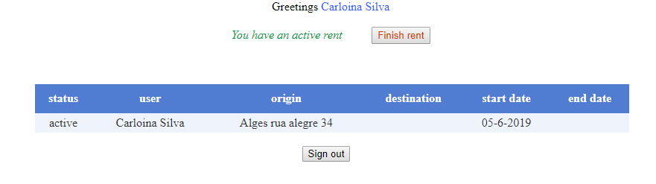

Finish rent page

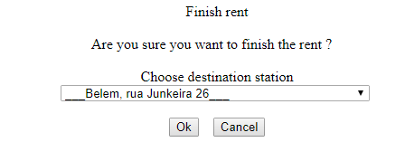

For the simplicity I didn’t create a pay_rent page. But it supposed to be here after the user has chosen destination station.

Assuming that the rent is calculated per day.

Updated user´s page

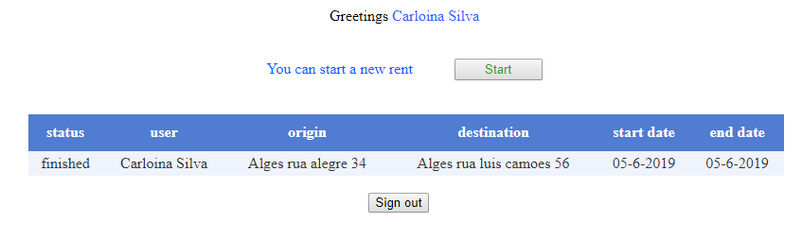

Example of the table rent

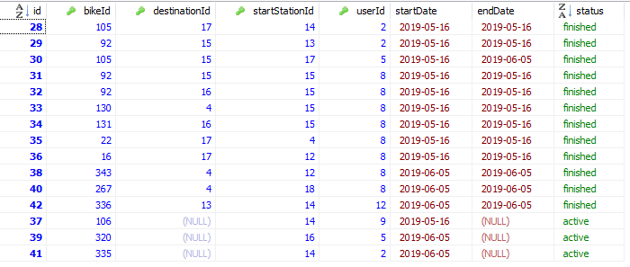

Example of a “good user” that has many rents

